### User-Provider Association

The Provider Directory contains information from the NPI Registry. User-Provider Association allows this information to be propagated within a user account.

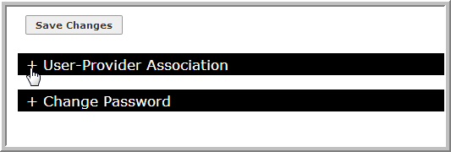

To begin, click **Associate** to search for the provider.

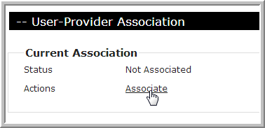

*First Name* and *Last Name* will be auto-populated from the basic user account information entered previously. Enter the provider’s NPI, if known, to narrow the search.

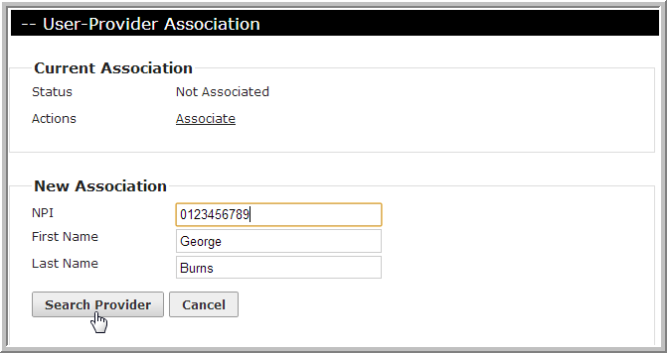

Results of the search will appear under *New Association*. Click **Associate** beside the correct result.

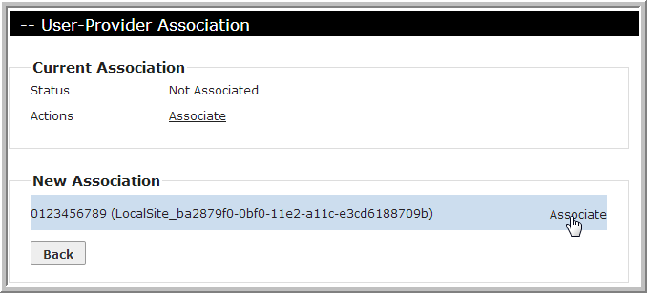

The user account is now associated with the entry in the Provider Directory. Click **Propagate User Information** to auto-populate data from the NPI Registry with corresponding fields in the user account.

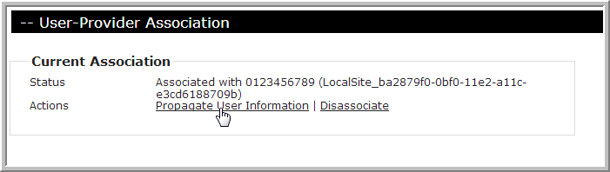

If the association was made in error or later needs to be removed, click **Disassociate** to remove the association.

Note: all information previously propagated in the user account must be manually removed.